S-100 – Part XX

Discovery Metadata for Information Exchange Catalogues

Page intentionally left blank

Contents

4a-1 Scope 1
4a-2 Conformance 1
4a-2.1 Conformance of this Profile with other Standards 1
4a-2.2 Backward compatibility 2
4a-3 Conformance to this Profile 2
4a-4 Normative references 2
4a-4.1 Profile definition 2
4a-4.2 Informative references 2
4a-5 Requirements 3
4a-5.1 Business purpose and Intended use 3
4a-5.2 Metadata for describing geographic data and other resources 4
4a-5.3 Obligations/conditions 5
4a-5.4 Minimum metadata requirements 5
4a-5.5 S-100 compliancy categories 11
4a-5.6 Recommended metadata for geographic datasets 11
4a-5.7 Variations and preferences 14
4a-5.7.1 Metadata element metadataIdentifier 14
4a-5.7.2 Metadata element parentMetadata 14
4a-5.7.3 Geographic extent of the dataset 14
4a-5.7.4 Data and Date Time information 14
4a-5.7.5 Metadata extension information 15
4a-5.8 Metadata for services 16
Appendix 4a-A Metadata Schema Class Information 19
Appendix 4a-B Data Dictionary 21
Appendix 4a-C Metadata Implementation 23
Appendix 4a-D Discovery Metadata for Information Exchange Catalogues 25
Appendix 4a-E Metadata Extensions 45

Page intentionally left blank

Scope
The S-100 Discovery Metadata for Information Exchange Catalogues profile described in this part provides a specification for describing and creating exchange catalogues that enables users to identify, discover and manage content of the S-100 exchange sets. More importantly it leverages XML to allow machine to machine discovery and exchange of information about about geographic datasets commonly produced by hydrographic organizations. Its purpose is the creation of metadata records that provide information about the identification, spatial and temporal extent, quality, application schema, spatial reference system, and distribution of digital geographic data. It is applicable to the cataloguing of datasets, clearinghouse activities, and the full description of geographic and non-geographic resources.
For information exchange, there are several categories of metadata required: metadata about the overall exchange catalogue, metadata about each of the datasets contained in the catalogue, and metadata about the support files that make up the package. If the exchange catalogue contains any Feature, Portrayal or Interoperability Catalogues there is a provision to carry additional metadata about those.

This document is intended for developers and implementers of metadata applications, and provides a basic understanding of the principles and the overall requirements for standardisation of geographic information. It should be used in conjunction with the standards listed under clause 4a-4 – Normative references.

Conformance

Conformance of this Profile with other Standards
The S-100 Discovery Metadata for Information Exchange Catalogues profile adopts data types defined in other ISO standards, mainly in ISO 19115 Geographic information - Metadata and ISO 19136 Geographic Information - Geography Markup Language, along with their underlying obligations and conditions. The XML schema references related to these external data types are embedded in the XML schemas for this profile, thus ensuring the conformance of this profile with other standards during authoring and validation of XML catalogue instances.

Conformance to this Profile
The conformance to this profile can be confirmed by validating XML catalogue instances against the S-100 Metadata Profile schemas which are available from the IHO S-100 repository.

Normative references
The following referenced documents are required for the application of this document. For dated references, only the edition cited applies. For undated references, the latest edition of the referenced document (including amendments) applies.

Profile definition
The following documents were the references used to define the S-100 Metadata Profile:
ISO 19115-1:2014, Geographic information – Metadata – Part 1 - Fundamentals
ISO 19115-1/Amdt01:2018, Geographic information – Metadata – Part 1 - Fundamentals (Amendment 1)
ISO 19115-2:2009, Geographic information - Metadata - Part 2: Extensions for imagery and gridded data
ISO 19119:2016, Geographic information – Services
ISO/TS 19115-3:2016, Geographic information - Metadata - XML schema implementation for fundamental concepts

Informative references
ISO 19115:2003, Geographic information – Metadata
ISO 19115:2003/Cor.1:2006, Geographic information - Metadata (Technical Corrigendum 1)
ISO/TS 19139:2007, Geographic information - Metadata - XML schema implementation

Overview

S-100 Exchange Set Structure
The S-100 Exchange Set is a data container that provides all the elements needed for a reliable and secure exchange of S-100 conformant data. It is intended to be a self-contained entity consisting of data files and metadata records packaged together using applicable data integrity and optional security provisions. The overall concept of the S-100 Exchange Set is a realization of the ISO 19115-3 classes, which fundamentally underpin the interchange of geospatial data and relevant metadata, as depicted in figure 4a-D-1.

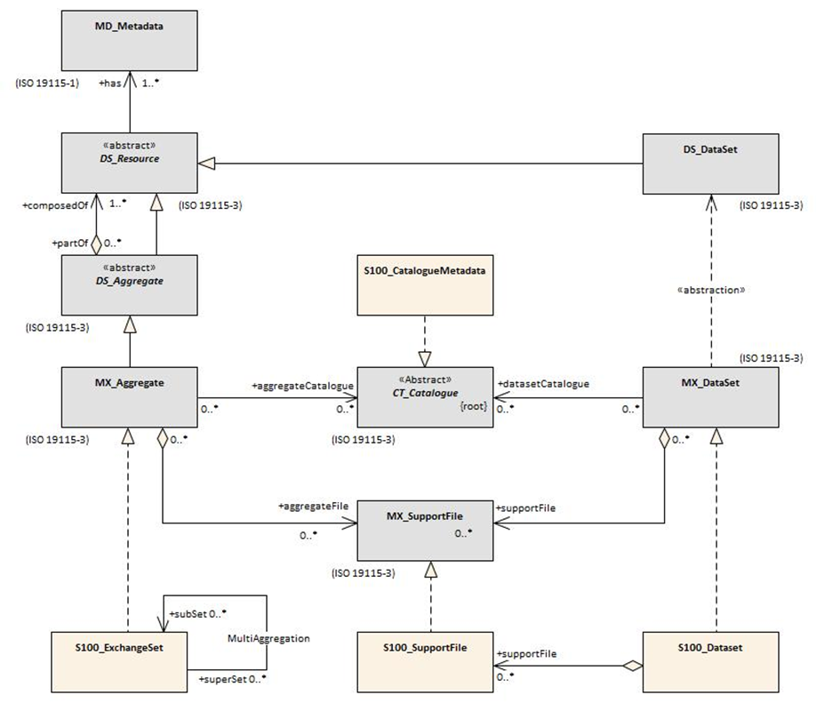
Figure 4a-D-1 Realization of the Exchange Set Classes

The above diagram illustrates the conceptual correspondence between data exchange provisions in ISO-19115 and S-100 standards. At an implementation level, the S-100 Exchange Set may include a combination of S-100 datasets, support files, and catalogue files along with the metadata information for all such resources in the form of the S-100 Exchange Set Catalogue. Conceptually this leads to the more detailed model, as shown in figure 4a-D-2.
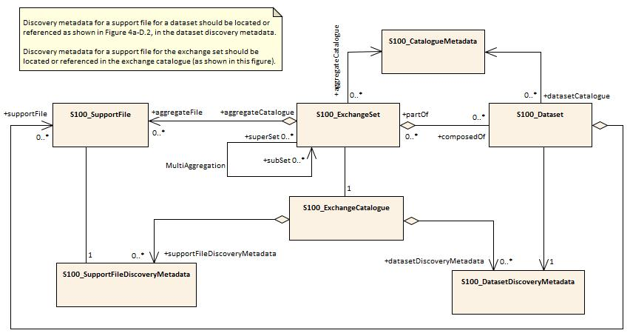
Figure 4a-D-2 – S-100 Exchange Set

The conceptual model depicted in Figure 4a-D-2 is very flexible and can be implemented in a variety of ways as virtually all components, except for the S-100_ExchangeCatalogue, are optional. This level of flexibility is essential to properly support the mainstream use case of exchanging geospatial data, as well as the use cases for releasing dataset cancellation notices or new catalogue releases without any data files present.
This approach ensures that an exchange set catalogue is always included in any S-100 conformant exchange set, providing the essential discovery metadata about any included resources and their intended use.
Preparation of an exchange set consists of packaging its components using a predefined file folder structure shown in figure 4a-D-3.

S-100 Exchange Set Folder Structure.
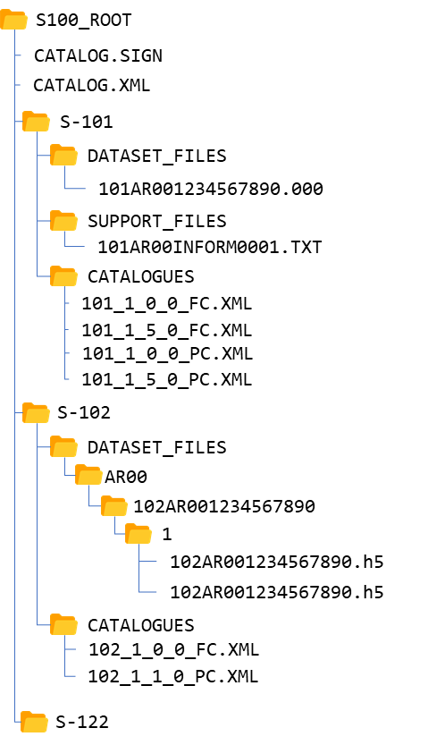
Figure 4a-D-3 – An S-100 Exchange Set Folder Structure

- An S-100 exchange set must contain an exchange set catalogue, CATALOG.XML, its digital signature CATALOG.SIGN and may contain any number of S-100 conformant dataset files, support files and catalogue files for other purposes.
- All S-100 content must be placed inside a top root folder named S100_ROOT. This is the only top level root folder in an exchange set containing only S-100 products.
- The S100_ROOT folder must contain a subfolder for each specific S-100 product specification data type included in the exchange set, e.g. S-101, S-104, S-102 (names defined in the IHO product specification register). These subfolders hold S-100 content specific to an individual product specification, all other exchange set files must be located in the S100_ROOT folder.
- Each product subfolder must contain subfolders for the component dataset files (DATASET_FILES), support files (SUPPORT_FILES) and catalogues (CATALOGUES) as required.
- The Iindividual data files, such as base dataset, update files or detailed ISO 19115 metadata may be optionally placed in their own subfolders or grouped together.
- Support files, on the other hand, should may be grouped together in one folder to prevent duplication across multiple dataset folders. Similarly, when needed, an exchange set may carry additional catalogues and/or their different versions which should also be grouped together in one folder.
- The required exchange set catalogue XML document instance must be named CATALOG.XML and placed at the root level alongside the S100_ROOT folder, together with its digital signature (CATALOG.SIGN) file. All other digital signatures are included within their corresponding resource metadata records in the CATALOG.XML.
An S-100 exchange set can be optionally defined alongside S-57 datasets with their own ENC_ROOT and INFO root folders as required by the S-57 ENC product specification. In this case there are three top level folders: ENC_ROOT and, INFO for S-57, and S100_ROOT with two separate catalogues covering their respective content (CATALOG.031 and CATALOG.XML). Figure 4a-D-43 demonstrates shows one of these use cases with S-57 and multiple S-100 products included. in an exchange set.
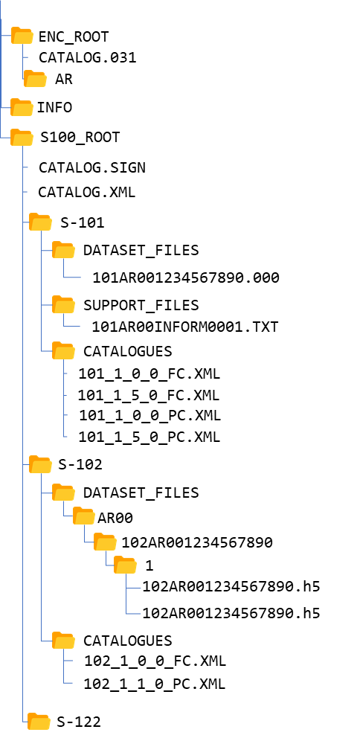
Figure 4a-D-4 – Combined S-100 and S-57 Exchange Sets Folder Structure

In addition to the folder structure, it is important to align the exchange set creation workflow with the data integrity and security provisions outlined in S-100 Part 15. These provisions cover digital signing, compression, and encryption of exchange set resources. All resources within an S-100 Exchange Set must be digitally signed and their signatures included in the exchange set catalogue. Data compression and encryption, are optional operations.
Exchange set creation, therefore, consists of:
- The creation of a suitable exchange set folder structure
- The arrangement of all resources in their designated folders.
- Creation of digital Ssignatures for all resources
- Optional compression and encryption of any resources which require it.
- Construction of an Exchange Set Catalogue which records the structure created.
S-100 Part 15 defines the requirements and process for creation and verification of digital signature values and production of compressed/encrypted datasets.

S-100 Exchange Set Catalogue
The S100 Exchange Set Catalogue is an XML document instance, which provides the metadata information needed to discover and use the resources contained in the S-100 Exchange Set. It must be named CATALOG.XML. This mandatory, central component of S-100 exchange sets consists of several components which capture suitable metadata records for each resource type. These components cover metadata for the exchange set catalogue, dataset discovery, support file discovery, any references to ISO 19115 dataset metadata, and additional catalogues as depicted in figure Figure 4a-D-4.
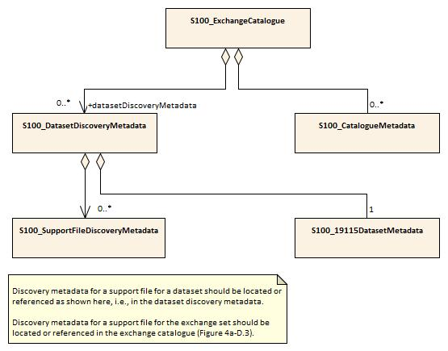
Figure 4a-D-4 – S-100 Exchange Set Catalogue

The discovery metadata subsections have attributes which enable important information about the datasets and accompanying support files to be examined without the need to process the data, for example encryption/compression flags. Similarly, other catalogues can be included in the S-100 Exchange Set, in support of the datasets, such as feature, portrayal, coordinate reference systems, codelists etc. Additionally, the S100 Exchange Set Catalogue provides mechanisms for managing the life cycle of datasets and support files. For example, the S-100 Support File Purpose enumeration within support file metadata provides revision control for support files.
More detailed information about the various elements of the catalogue is shown in Figure 4a-D-5 and in the textual description in the tables at clause 3.

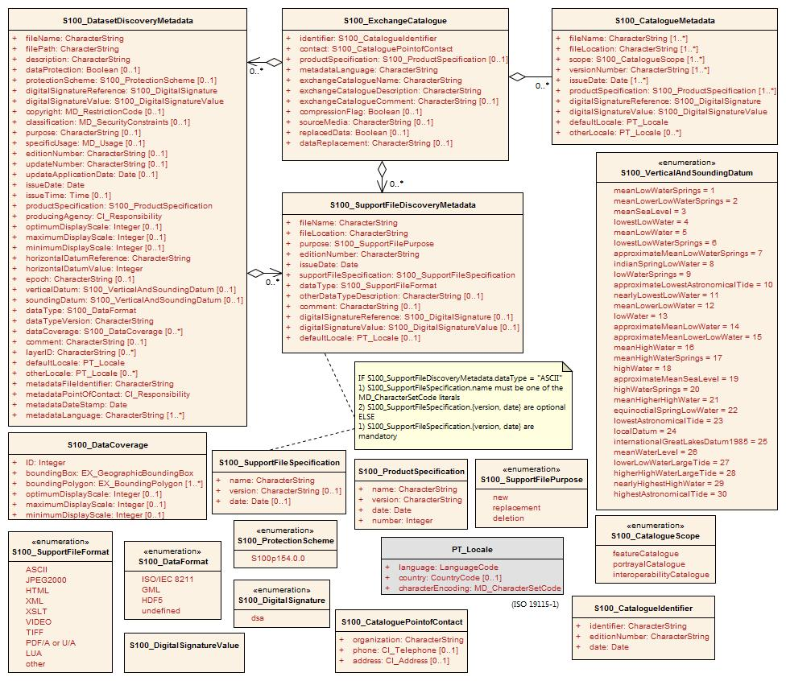
Figure 4a-D-5 – S-100 Exchange Set Catalogue - class details

Page intentionally left blank

Elements of the exchange set

S100_ExchangeCatalogue
Each exchange set has a single S100_ExchangeCatalogue which contains meta information for the data and support files in the exchange set.
Role Name | Name | Description | Mult | Type | Remarks
Class | S100_ExchangeCatalogue | An exchange catalogue contains the discovery metadata about the exchange datasets and support files | - | - | -
Attribute | identifier | Uniquely identifies this exchange catalogue | 0..1 | S100_CatalogueIdentifier
Attribute | contact | Details about the issuer of this exchange catalogue | 0..1 | S100_CataloguePointOfContact
Attribute | productSpecification | Details about the product specifications used for the datasets contained in the exchange catalogue | 0..* | S100_ProductSpecification
Attribute | metadataLanguage | Details about the Language | 0..1 | PT_Locale | Default without this is English
Attribute | exchangeCatalogueDescription | Description of what the exchange catalogue contains | 0..1 | CharacterString
Attribute | exchangeCatalogueComment | Any additional Information | 0..1 | CharacterString
Attribute | exchangeCatalogueCertificate | Signed public key certificates referred to by digital signatures in the exchange set | 0..* | exchangeCatalogueType | Content defined in S-100 Part 15. All certificates used, except the SA root certificate (installed separately by the implementing system) shall be included.
Role | datasetDiscoveryMetadata | Exchange catalogues may include or reference discovery metadata for the datasets in the exchange set | 0..* | Aggregation S100_DatasetDiscoveryMetadata
Role | catalogueDiscoveryMetadata-- | Metadata for catalogue | 0..* | Aggregation S100_CatalogueDiscoveryMetadata | Metadata for the feature, portrayal, and interoperability catalogues, if any
Role | supportFileDiscoveryMetadata | Exchange catalogues may include or reference discovery metadata for the support files in the exchange set | 0..* | Aggregation S100_SupportFileDiscoveryMetadata

S100_ExchangeCatalogueIdentifier
Role Name | Name | Description | Mult | Type | Remarks
Class | S100_ExchangeCatalogueIdentifier | An exchange catalogue contains the discovery metadata about the exchange datasets and support files | - | - | The concatenation of identifier, editionNumber and dateTime form the unique name
Attribute | identifier |  | 1 | CharacterString | Uniquely identifies this exchange catalogue  <S100XC:identifier>US_101_20200101_120101_01</S100XC:identifier>
Attribute | dateTime | Creation date and time of the exchange catalogue, including time zone | 1 | DateTime | Format: yyyymmddThhmmssZ

S100_CataloguePointofContact
Role Name | Name | Description | Mult | Type | Remarks
Class | S100_CataloguePointOfContact | Contact details of the issuer of this exchange catalogue | - | - | -
Attribute | organization | The organization distributing this exchange catalogue | 1 | CharacterString | This could be an individual producer, value added reseller, etc.
Attribute | phone | The phone number of the organization | 0..1 | CI_Telephone
Attribute | address | The address of the organization | 0..1 | CI_Address

S100_ ExchangeCatalogueCertificateType
Role Name | Name | Description | Code | Remarks | Data
Enumeration | S100_ExchangeCatalogueCertificateType | Certificate for digital signature | - | -
Attribute | id | The data server id | - |  | e.g. “UKHO”, “PRIMAR”
Attribute | signedPublicKey | The data server’s public key | 1 | CharacterString

S100_DatasetDiscoveryMetadata
Role Name | Name | Description | Mult | Type | Remarks
Class | S100_DatasetDiscoveryMetadata | Metadata about the individual datasets in the exchange catalogue | - | - | -
Attribute | fileName | Dataset file name | 1 | CharacterString
Attribute | fileLocation | Full location from the exchange set root directory | 0..1 | S100_FileLocation | Without fileLocation the exchange set is unpacked into directory <ROOT>/S100_ROOT/DATASET_FILES/<fileName>
Attribute | description | Short description giving the area or location covered by the dataset | 0..1 | CharacterString | For example, a harbour or port name, between two named locations etc.
Attribute | compressionFlag | Is the data compressed | 0..1 | Boolean | Yes or No
Attribute | dataProtection | Indicates if the data is encrypted | 0..1 | Boolean | 0 indicates an unencrypted dataset  1 indicates an encrypted dataset
Attribute | protectionScheme | Specification or method used for data protection | 0..1 | S100_ProtectionScheme | For example S-63
Attribute | digitalSignatureReference | Digital Signature of the file | 1 | S100_DigitalSignature | Specifies the algorithm used to compute digitalSignatureValue
Attribute | digitalSignatureValue | Value derived from the digital signature | 1..* | S100_DigitalSignatureValue | The value resulting from application of digitalSignatureReference  Implemented as the digital signature format specified in Part 15
Attribute | copyright | Indicates if the dataset is copyrighted | 0..1 | Boolean
Attribute | classification | Indicates the security classification of the dataset | 0..1 | Class MD_SecurityConstraints>MD_ClassificationCode (codelist) | 1. unclassified  2. restricted  3. confidential  4. secret  5. top secret  6. sensitive but unclassified  7. for official use only  8. protected  9. limited distribution
Attribute | purpose | The purpose for which the dataset has been issued | 0..* | S100_Purpose  (codelist)
Attribute | specificUsage | The use for which the dataset is intended | 0..1 | MD_USAGE>specificUsage (character string) | For example, in the case of ENCs this would be a Navigational Purpose classification. This is strictly for discovery catalogue purposes
Attribute | editionNumber | The edition number of the dataset | 0..1 | Integer | When a data set is initially created, the edition number 1 is assigned to it. The edition number is increased by 1 at each new edition. Edition number remains the same for a re-issue.
Attribute | updateNumber | Update number assigned to the dataset and increased by one for each subsequent update | 0..1 | Integer | Update number 0 is assigned to a new dataset
Attribute | updateApplicationDate | This date is only used for the base cell files (that is new data set, re-issue and new edition), not update cell files. All updates dated on or before this date must have been applied by the producer | 0..1 | Date
Attribute | issueDate | Date on which the data was made available by the data producer | 1 | Date
Attribute | issueTime | Time of day at which the data was made available by the data producer | 0..1 | Time | The S-100 datatype Time
Attribute | boundingBox | The extent of the dataset limits | 0..1 | EX_GeographicBoundingBox | -
Attribute | productSpecification | The product specification used to create this dataset | 1 | S100_ProductSpecification
Attribute | producingAgency | Agency responsible for producing the data | 1 | CI_Responsibility>CI_Organisation | See Tables 4a-2
Attribute | horizontalDatumReference | Reference to the register from which the horizontal datum value is taken | 1 | characterString | For example, EPSG
Attribute | horizontalDatumValue | Horizontal Datum of the entire dataset | 1 | Integer | For example, 4326
Attribute | epoch | Code denoting the epoch of the geodetic datum used by the CRS | 0..1 | CharacterString | For example, G1762 for the 2013-10-16 realization of the geodetic datum for WGS84
Attribute | verticalDatum | Vertical Datum of the entire dataset | 0..1 | S100_VerticalAndSoundingDatum
Attribute | soundingDatum | Sounding Datum of the entire dataset | 0..1 | S100_VerticalAndSoundingDatum
Attribute | encodingFormat | The encoding format of the dataset | 1 | S100_EncodingFormat
Attribute | dataCoverage | Provides information about data coverages within the dataset | 0..* | S100_DataCoverage
Attribute | comment | Any additional information | 0..1 | CharacterString
Attribute | defaultLocale | Default language and character set used in the dataset | 0..1 | PT_Locale | In absence of defaultLocale the language is English
Attribute | otherLocale | Other languages and character sets used in the dataset | 0..* | PT_Locale
Attribute | metadataPointOfContact | Point of contact for metadata | 0..1 | CI_Responsibility>CI_Individual or  CI_Responsibility>CI_Organisation | Only if metadataPointOfContact is different to producingAgency
Attribute | metadataDateStamp | Date stamp for metadata | 0..1 | Date | May or may not be the issue date
Attribute | replacedData | If a data file is cancelled is it replaced by another data file | 0..1 | Boolean
Attribute | dataReplacement | Cell name | 0..* | CharacterString | A dataset may be replaced by 1 or more datasets
Role | -- | Containment of, or reference to, discovery metadata for the support files referenced in the dataset | 0..* | Aggregation S100_SupportFileDiscoveryMetadata

S100_DataCoverage
Role Name | Name | Description | Mult | Type | Remarks
Class | S100_DataCoverage | A spatial extent where data is provided; and the display scale information for the provided data | - | - | This field is used by user systems as part of the data loading and unloading algorithms and it is strongly encouraged that product specifications mandate the use of one or more of the displayScale provided as part of S100_DataCoverage
Attribute | ID | Uniquely identifies the coverage | 1 | Integer | -
Attribute | boundingPolygon | A polygon which defines the actual data limit | 1..1 | EX_BoundingPolygon
Attribute | optimumDisplayScale | The scale with which the data is optimally displayed | 0..1 | Integer | Example: A scale of 1:25000 is encoded as 25000
Attribute | maximumDisplayScale | The maximum scale with which the data is displayed | 0..1 | Integer
Attribute | minimumDisplayScale | The minimum scale with which the data is displayed | 0..1 | Integer

S100_DigitalSignature
Role Name | Name | Description | Code | Remarks
Enumeration | S100_DigitalSignature | Algorithm used to compute the digital signature | - | -
Value | dsa | Digital Signature Algorithm | - | FIPS 186-4 (2013)

S100_DigitalSignatureValue
Role Name | Name | Description | Mult | Type | Remarks
Class | S100_DigitalSignatureValue | Signed Public Key plus the digital signature | - | - | Data type for encoding digital signature values
Attribute | dataServerCertificate | Data Server Certificate as defined in S-100 Part 15 | 0..1 | CharacterString | A certificate will be encoded in PEM format as a character string as defined in S-100 Part 15. Optional. digitalSignature can use ref to refer to certificates defined in S100_ExchangeCatalogue to avoid repetition.
Attribute | digitalSignature | Digital signature as defined in S-100 Part 15 | 1 | CharacterString | A digital signature will be in ASN.1 in base64 and encoded as a character string as defined in S-100 Part 15.

S100_FileLocation
Role Name | Name | Description | Mult | Type | Remarks
Class | S100_FileLocation | Full location relative to the exchange set root directory |  | - | -
Attribute | fileName | Name of the dataset file | 1 | CharacterString
Attribute | filePath | Path Relative to the root directory | 1 | CharacterString | Path relative to the root directory of the exchange set. The location of the file after the exchange set is unpacked into directory <ROOT> will be <ROOT>/<fileLocation>/<fileName>.  If fileLocation is undefined the file is located in the appropriate directory as per the folder structure defined in 4a-4.2

S100_Purpose
Role Name | Name | Description | Code | Remarks
Enumeration | S100_Purpose | The Purpose of the Dataset | -
Value | New dataset | Brand New dataset | - | -
Value | New Edition | New edition of the dataset | - | -
Value | Update | Dataset update |  | -
Value | reissue | Dataset that has been re-issued | -
Value | cancellation | Dataset that has been cancelled
Value | delta | Dataset difference
Value | navigation | Dataset Intended for navigation
Value | notForNavigation | Dataset not intended for navigation

S100_VerticalAndSoundingDatum
Role Name | Name | Description | Code | Remarks
Enumeration | S100_VerticalAndSoundingDatum | Allowable vertical and sounding datums | - | -
Value | meanLowWaterSprings |  | 1 | (MLWS)
Value | meanLowerLowWaterSprings |  | 2 | -
Value | meanSeaLevel |  | 3 | (MSL)
Value | lowestLowWater |  | 4 | -
Value | meanLowWater |  | 5 | (MLW)
Value | lowestLowWaterSprings |  | 6 | -
Value | approximateMeanLowWaterSprings |  | 7 | -
Value | indianSpringLowWater |  | 8 | -
Value | lowWaterSprings |  | 9 | -
Value | approximateLowestAstronomicalTide |  | 10 | -
Value | nearlyLowestLowWater |  | 11 | -
Value | meanLowerLowWater |  | 12 | (MLLW)
Value | lowWater |  | 13 | (LW)
Value | approximateMeanLowWater |  | 14 | -
Value | approximateMeanLowerLowWater |  | 15 | -
Value | meanHighWater |  | 16 | (MHW)
Value | meanHighWaterSprings |  | 17 | (MHWS)
Value | highWater |  | 18 | (HW)
Value | approximateMeanSeaLevel |  | 19 | -
Value | highWaterSprings |  | 20 | -
Value | meanHigherHighWater |  | 21 | (MHHW)
Value | equinoctialSpringLowWater |  | 22 | -
Value | lowestAstronomicalTide |  | 23 | (LAT)
Value | localDatum |  | 24 | -
Value | internationalGreatLakesDatum1985 |  | 25 | -
Value | meanWaterLevel |  | 26 | -
Value | lowerLowWaterLargeTide |  | 27 | -
Value | higherHighWaterLargeTide |  | 28 | -
Value | nearlyHighestHighWater |  | 29 | -
Value | highestAstronomicalTide |  | 30 | (HAT)
Value | ITRF2014 | International Terrestrial Reference Frame 2014 | 31
Value | ITRF2020 | International Terrestrial Reference Frame 2020 | 32
Value | ellipsoidalHeightGeneric |  | 33
Value | balticSeaChartDatum2000 |  | 34
Value | geoidGeneric |  | 35
Value | internationalGreatLakesDatum2020 |  | 36
Value | seaSurface |  | 37 | Local sea bottom
Value | seaBottom |  | 38 | Local sea bottom reference

Note: The numeric codes are the codes specified in the IHO GI Registry for the equivalent listed values of the IHO Hydro domain attribute Vertical datum, since the registry does not at present (20 June 2018) contain entries for exchange set metadata and dataset metadata attributes.

S100_EncodingFormat
Role Name | Name | Description | Code | Remarks
Enumeration | S100_DataFormat | The encoding format | - | -
Value | ISO/IEC 8211 | The ISO 8211 data format as defined in Part 10a | - | -
Value | GML | The GML data format as defined in Part 10b | - | -
Value | HDF5 | The HDF5 data format as defined in Part 10c |  | -
Value | undefined | The encoding is defined in the Product Specification | - | Use product specification specific encoding means the data product and product specification is not intended for an IHO S-100 compliant system.

S100_ProductSpecification
Role Name | Name | Description | Mult | Type | Remarks
Class | S100_ProductSpecification | The Product Specification contains the information needed to build the specified product | - | - | -
Attribute | name | The name of the product specification used to create the datasets | 0..1 | CharacterString | The name in the GI Registry should be used for this field
Attribute | version | The version number of the Product Specification | 0..1 | CharacterString | TR 2/2007 specifies versioning of product specifications.
Attribute | date | The version date of the product specification | 0..1 | Date
Attribute | number | The number used to lookup the product in the Product Specification Register of the IHO GI registry | 0..1 | Integer | From the Product Specification Register, in the IHO Geospatial Information Registry
Attribute | compliancyCategory | The level of compliance of the Product Specification to S-100 | 0..1 | S100_CompliancyCategory | See clause Part 4a-5.5

S100_CompliancyCategory
Role Name | Name | Description | Code | Remarks
Enumeration | S100_CompliancyCategory |  | - | -
Value | category1 | IHO S-100 object model compliant
Value | category2 | IHO S-100 compliant with non-standard encoding
Value | category3 | IHO S-100 compliant with standard encoding
Value | category4 | IHO S-100 and IMO harmonized display compliant

S100_ProtectionScheme
Role Name | Name | Description | Code | Remarks
Enumeration | S100_ProtectionScheme | Data protection schemes | - | -
Value | S100p15 | IHO S-100 Part 15 | - | See Part 15

S100_SupportFile
Role Name | Name | Description | Mult | Type | Remarks
Class | S100_SupportFile |  | - | - | -
Role | aggregateFile | Collection of support files | 0..* | -
Role | supportFile | File which has information about a dataset | 0..* | -

S100_SupportFileDiscoveryMetadata
Role Name | Name | Description | Mult | Type | Remarks
Class | S100_SupportFileDiscoveryMetadata | Metadata about the individual support files in the exchange catalogue | - | - | -
Attribute | fileName | Name of the support file | 1 | CharacterString
Attribute | fileLocation | Full location from the exchange set root directory | 1 | CharacterString | Path relative to the root directory of the exchange set. The location of the file after the exchange set is unpacked into a directory <ROOT> will be <ROOT>/S100_ROOT/<fileLocation>/<filename>.  If fileLocation is undefined the file is located in <ROOT>/S100_ROOT/SUPPORT_FILES/fileName
Attribute | purpose | The purpose for which the support file has been issued | 1 | S100_SupportFilePurpose | For example new, re-issue, new edition, update etc.
Attribute | editionNumber | The edition number of the support file | 1 | Integer | When a data set is initially created, the edition number 1 is assigned to it. The edition number is increased by 1 at each new edition. Edition number remains the same for a re-issue
Attribute | issueDate | Date on which the data was made available by the data producer | 0..1 | Date
Attribute | supportFileSpecification | The specification used to create this file | 0..1 | S100_SupportFileSpecification
Attribute | dataType | The format of the support file | 1 | S100_SupportFileFormat
Attribute | otherDataTypeDescription | Support file format other than those listed | 0..1 | CharacterString
Attribute | comment | Optional comment | 0..1 | CharacterString
Attribute | compressionFlag | Is the data compressed | 0..1 | Boolean | Yes or No
Attribute | digitalSignatureReference | Digital Signature of the file | 0..1 | CharacterString | Reference to the appropriate digital signature algorithm
Attribute | digitalSignatureValue | Value derived from the digital signature | 1..* | S100_DigitalSignatureValue | The value resulting from application of digitalSignatureReference  Implemented as the digital signature format specified in Part 15
Attribute | defaultLocale | Default language and character set used in the exchange catalogue | 0..1 | PT_Locale | A support file is expected to use only one locale, because other files can be created for other languages

S100_SupportFileFormat
Role Name | Name | Description | Code | Remarks
Enumeration | S100_SupportFileFormat | The format used for the support file | - | -
Value | ASCII | UTF-8 text excluding control codes | - | Many files use UTF-8
Value | JPEG2000 | JPEG2000 format | - | ISO 15444
Value | HTML | Hypertext Markup Language | -
Value | XML | Extensible Markup Language | -
Value | XSLT | Extensible Stylesheet Language Transformations | -
Value | VIDEO | Representation of moving images in unspecified format | -
Value | TIFF | Tagged Image File Format | -
Value | PDF/A or UA | Portable Document Format | - | ISO 19005, ISO 32000  Product Specification developers should take careful consideration in using PDF as a support file format. It is recommended that PDF never be used in products that will be used on a navigation system as it may impair night vision
Value | LUA | Lua programming language | -
Value | other | Other format | -

S100_SupportFilePurpose
Role Name | Name | Description | Code | Remarks
Enumeration | S100_SupportFilePurpose | The reason for inclusion of the support file in this exchange set | - | -
Value | new | A file which is new | - | Signifies a new file
Value | replacement | A file which replaces an existing file | - | Signifies a replacement for a file of the same name
Value | deletion | Deletes an existing file | - | Signifies deletion of a file of that name

S100_SupportFileSpecification
Role Name | Name | Description | Mult | Type | Remarks
Class | S100_SupportFileSpecification | The standard or specification to which a support file conforms | - | - | -
Attribute | name | The name of the specification used to create the support file | 1 | CharacterString
Attribute | version | The version number of the specification | 0..1 | CharacterString
Attribute | date | The version date of the specification | 0..1 | Date

S100_CatalogueDiscoveryMetadata
Role Name | Name | Description | Mult | Type | Remarks
Class | S100_CatalogueDiscoveryMetadata | Class for S-100 catalogue metadata | - | - | -
Attribute | fileName | The name for the catalogue | 1 | S100_FIleName
Attribute | purpose | The purpose for which the dataset has been issued | 0..1 | S100_Purpose  (codelist) | 2. new edition  5. cancellation  Default is value 2:new edition
Attribute | fileLocation | Full location from the exchange set root directory | 1 | CharacterString | Path relative to the root directory of the exchange set. The location of the file after the exchange set is located in a directory <ROOT> will be <ROOT>/<fileLocation>/<fileName>  If fileLocation is undefined then the file will be located in <ROOT>/S100_ROOT/CATALOGUES/<fileName>
Attribute | scope | Subject domain of the catalogue | 1 | S100_CatalogueScope
Attribute | versionNumber | The version number of the product specification | 1 | CharacterString
Attribute | issueDate | The version date of the product specification | 1 | Date
Attribute | productSpecification | The product specification used to create this file | 0..1 | S100_ProductSpecification
Attribute | digitalSignatureReference | Digital Signature of the file | 1 | S100_DigitalSignature | Reference to the appropriate digital signature algorithm
Attribute | digitalSignatureValue | Value derived from the digital signature | 1..* | S100_DigitalSignatureValue | The value resulting from application of digitalSignatureReference  Implemented as the digital signature format specified in Part 15
Attribute | defaultLocale | Default language and character set used in the exchange catalogue | 1 | PT_Locale
Attribute | otherLocale | Other languages and character sets used in the exchange catalogue | 0..* | PT_Locale

S100_CatalogueScope
Role Name | Name | Description | Code | Remarks
Enumeration | S100_CatalogueScope | The scope of the catalogue | - | -
Value | featureCatalogue | S-100 feature catalogue
Value | portrayalCatalogue | S-100 portrayal catalogue
Value | interoperabilityCatalogue | S-100 interoperability information

S100_SV_ServiceIdentification
Role Name | Name | Description | Mult | Type | Remarks
Class | S100_SV_ServiceIdentitification | Identification of capabilities which a service provider makes available to a service user through a set of interfaces which define a behaviour | - | - | Specialization of SV_ServiceIdentification (ISO 19115-1) and thereby a specialization of MD_Identification  (The ISO attributes coupledResource and couplingType are not used.)
(Inherited properties) | (Inherited from SV_ServiceIdentification.)
Attribute | serviceType | A service type name | 1 | Class GenericName | GenericName is an abstract class for all names in a NameSpace. Each instance of a GenericName is either a LocalName or a ScopedName. A LocalName references a local object directly accessible from the NameSpace. A ScopedName is a composite of a LocalName for locating another NameSpace and a GenericName valid in the NameSpace. (ISO 19103). In short: A name that is defined in a namespace.  For S-100 services, the recommended namespace is the IALA/IMO/IHO list of Maritime Services (TBD as of May 2018)
Attribute | serviceTypeVersion | The version of the service, supports searching based on the version of serviceType | 0..* | CharacterString
Attribute | accessProperties | Information about the availability of the service, including fees, planned available date and time, ordering instructions, turnaround | 0..1 | MD_StandardOrderProcess | ISO 19115-1 B.11.5
Attribute | operatedDataset | Provides a reference to the resource on which the service operates | 0..* | CI_Citation | For any single resource referenced, only one of operatedDataset or operatesOn is allowed to be documented (not both for the same resource)
Attribute | profile | Profile to which the service adheres | 0..* | CI_Citation | profile of the standard cited in serviceStandard  The specification for the data product can be identified here
Attribute | serviceStandard | Standard to which the service adheres | 0..* | CI_Citation | For example, citation for OGC WFS, WMS, etc.
Role | operatesOn |  | 0..* | MD_DataIdentification | For any single resource referenced, only one of operatedDataset or operatesOn is allowed to be documented (not both for the same resource)
(Inherited properties) | (Inherited from MD_Identification.) (not shown)

PT_Locale
Role Name | Name | Description | Mult | Type | Remarks
Class | PT_Locale | Description of a locale | - | - | From ISO 19115-1
Attribute | language | Designation of the locale language | 1 | LanguageCode | ISO 639-2 3-letter language codes.
Attribute | country | Designation of the specific country of the locale language | 0..1 | CountryCode | ISO 3166-2 2-letter country codes
Attribute | characterEncoding | Designation of the character set to be used to encode the textual value of the locale | 1 | MD_CharacterSetCode | Use (the “Name” from the) IANA Character Set register: http://www.iana.org/assignments/character-sets. (ISO 19115-1 B.3.14)  For example, UTF-8

The class PT_Locale is defined in ISO 19115-1. LanguageCode, CountryCode, and MD_CharacterSetCode are ISO codelists which should either be defined in resource files and encoded as (string) codes, or represented by the corresponding literals from the namespaces identified in the Remarks column.
XML encoding example:
See April2020\S100 Edition 4.0.0 Schemas_FINAL\samples\S101\1.0.0\CATALOG.XML
<lan:PT_Locale>
<lan:language>
<lan:LanguageCode codeList="http://www.iho.int/S100/4.0.0/resources/Codelists/cat/codelists.xml#S100_MD_LanguageCode" codeListValue="eng">English</lan:LanguageCode>
</lan:language>
<lan:characterEncoding>
<lan:MD_CharacterSetCode codeList="http://www.iho.int/S100/4.0.0/resources/Codelists/cat/codelists.xml#S100_MD_CharacterSetCode" codeListValue="UTF-8">UTF-8</lan:MD_CharacterSetCode>
</lan:characterEncoding>
</lan:PT_Locale>

